ESET 359 Final Project Report

Nikita Choudhary
Electronics Systems Engineering Technology
Texas A&M University
College Station
nikitachoudhary@tamu.edu
Noah Tennison
Electronics Systems Engineering Technology
Texas A&M University
College Station, USA
noahtennison2@tamu.edu

Abstract— This project aims to use a LabVIEW VI, circuit configuration, and electrodes to make Mario move left/right or jump in the Mario game.
Keywords—LabVIEW VI, electrodes

Introduction
This report demonstrates how the project uses the LabVIEW VI, circuit configuration, and electrodes to make Mario move left/right or jump in the Mario game. This report will demonstrate: (1) the VI and (2) the circuit configuration used to create the Mario control system. This report will also demonstrate: (3) the results seen in the Mario game, (4) the Excel file, (5) the Appendix, and (6) useful applications of using EMG. A table will be used to display the logic behind the VI with respect to which electrode (electrode on left or right bicep) senses muscle movement.

THE VI

The Front Panel
Figure 1 displays the front panel of the VI. The waveform charts read the muscle movement on the left and right biceps. The readings from both biceps are converted to either a binary 1 or a binary 0. Mario will jump or move left/right depending on which electrode (one on the right or left biceps) is a binary 1 or binary 0. This is seen in Table 1.

The Block Diagram
Figure 2 displays the block diagram. It sends the conditioned EMG signals through a low-pass filter to obtain the envelope of the signal. With the use of comparators, a binary value is assigned to whether the right bicep is contracting or the left bicep is contracting. The combination of both values determines whether Mario will move left, move right, or jump. Ideally, if the left arm is contracting, Mario should move left. If the right arm is contracting, Mario should move right. If both arms are contracting, Mario should jump. The VI will also create an Excel file that will display the binary values of the electrodes on each bicep as well as Mario’s movement. UART (Universal Asynchronous Receiver/Transmitter) is used to transmit the signals from the electrodes to the LabVIEW program.

The Circuit Configuration
Figure 3 displays the circuit configuration for the final project. This circuit configuration utilizes an instrumentation amplifier and a band-pass filter for each bicep. The instrumentation amplifier is connected in series to the band-pass filter. Pins 2 and 3 of the instrumentation amplifiers are connected directly to the biceps. Pin 5 of the instrumentation amplifier is the reference voltage, which is connected to the left and right wrists. Pin 6 of the instrumentation amplifier is connected to the input of the band-pass filter. Pins 7 and 4 of the instrumentation amplifier are connected to the positive and negative 5 supply, respectively. The output of the band-pass filter is connected to one of the input pins. In other words, the VI reads the band-pass filter output.

The Results
After creating the VI and configuring the circuit, Mario performed the movements in the Mario game with fair success. Mario moved left and right as expected when either the left or right biceps muscle was stressed. Mario also did not move successfully when neither of the biceps muscles was stressed. However, Mario initially did not jump as expected when both biceps muscles were stressed. Mario only jumped sometimes, but not all the time, when both biceps muscles were stressed. This was fixed by correcting the VI and replacing the electrodes in a better spot.

The Excel File
Initially, there were difficulties creating the Excel file. The Excel file does not record any of Mario’s jump movement. However, the binary values for the electrodes on the left and right biceps match the other movement Mario performs in the game.

Appendix

Tables
- Mario’s movement based on Binary value of electrode on left/right bicep
Mario’s Movement | Binary Value
 | Electrode on Left Bicep | Electrode on Right Bicep
None | 0 | 0
Move Right | 0 | 1
Move Left | 1 | 0
Jump | 1 | 1

Figures
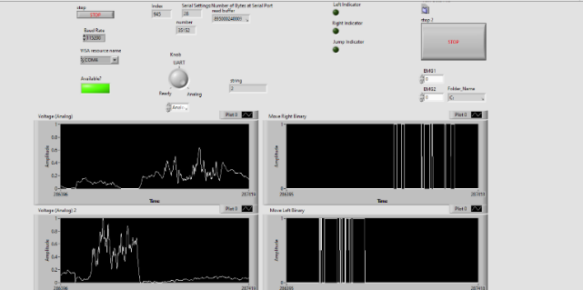
- Front Panel for Final Project
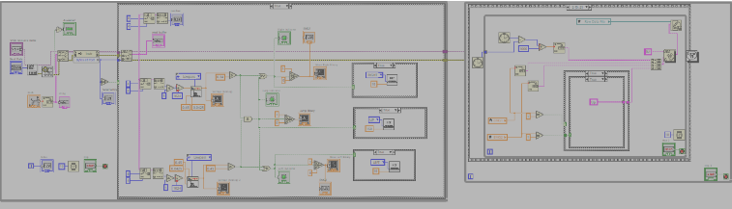
- Block diagram for the final project
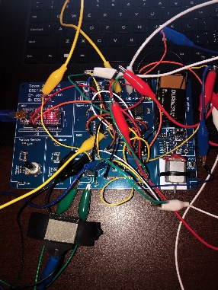
- The circuit configuration for the final project

Useful applications of using EMG
EMG can be very helpful for clinical and biomedical applications such as Evolvable Hardware Chip (EHW) development and modern human-computer interaction. In order for this to work, the EMG signals from muscles require methods for detection, decomposition, processing, and classification. Firstly, with regard to modern human-computer interaction, management and rehabilitation in motor disability is an area where EMG is utilized. This involves prosthetic hand control, grasp recognition, and human-machine interaction. In addition, EMG can be very helpful for people with neurological diseases. Acquiring the shapes and firing rates of Motor Unit Action Potentials (MUAPs) in EMG signals helps acquire information in order to diagnose someone with a neuromuscular disorder. On the topic of motor control, EMG signals can also be very useful in exercise fatigue assessment. Exercise fatigue assessment specifically refers to fatigue that arises from human activities resulting in a decrease in one’s physical performance (or muscle fatigue). This exercise fatigue can be detected as a constant load from exercise increasing EMG activity. The more muscle contractions that are generated, the more electrical currents are generated. This, in turn, displays EMG signals on the computer. EMG can also be used for kinesiology. Specifically, EMG for patients can be used as a form of biofeedback to examine the kinesiological function of a muscle while it moves. More information can also be found about this through Motion Analysis, Force or Pressure Distribution measurements. This is very helpful for individuals who are in physical therapy, as acquiring this information can help detect coordination changes over time. Recognizing all of these uses of EMG, it can be concluded that EMG has a variety of different uses and will only get better with continued development, especially in biomedical fields.

References
- E. D. Oña, S. Marcos-Antón, D.-S. Copaci, J. Arias, R. Cano-de-la-Cuerda, and A. Jardón, “Effects of EMG-Controlled Video Games on the Upper Limb Functionality in Patients with Multiple Sclerosis: A Feasibility Study and Development Description,” Computational Intelligence and Neuroscience, vol. 2022, pp. 1–16, Apr. 2022, doi: https://doi.org/10.1155/2022/3735979.
- J. Sun, G. Liu, Y. Sun, K. Lin, Z. Zhou, and J. Cai, “Application of surface electromyography in exercise fatigue: A Review,” Frontiers, 07-Jun-2022.[Online].Available:https://www.frontiersin.org/articles/10.3389/fnsys.2022.893275/full. [Accessed: 28-Apr-2023].
- “Learn more about EMG,” UW. [Online]. Available: https://www.uwlax.edu/grad/physical-therapy/learn-more-about-emg/. [Accessed: 28-Apr-2023].
- ‌M. B. I. Reaz, M. S. Hussain, and F. Mohd-Yasin, “Techniques of EMG signal analysis: detection, processing, classification and applications,” Biological Procedures Online, vol. 8, no. 1, pp. 11–35, Dec. 2006, doi: https://doi.org/10.1251/bpo115.
- V. Medved and M. Cifrek, “Kinesiological electromyography,” IntechOpen, 09-Sep-2011. [Online]. Available: https://www.intechopen.com/chapters/19664. [Accessed: 28-Apr-2023]

